Content Page……………………………………………………………………Page Number

1. Introduction ……………………………………………………………… 2
2. Discussion………………………………………………………………...
   1. Art in Wales (Landscape) ………………………………………..
   2. Welsh Pottery and Porcelain…………………………………….. 3
   3. The Evolution of Wales…………………………………………. 4
3. Conclusion……………………………………………………………….
4. Reference List…………………………………………………………… 5
5. Introduction

The national museum of Wales or in Welsh language (Amgueddfa Genedlaethol Caerdydd) was established in 1912 and located in Cathays Park, Cardiff in Wales (National Museum of Wales 2016). In addition, many different international visitors come to explore the museum and learn more about Wales and the United Kingdom history in general. Since the museum is available for everyone, it keeps its identity by providing Welsh language along with the dominant English language to educate the visitors about the items and pieces in the museum. It also holds an important part of the Welsh culture where it reflects it many different aspects for example in Historic Art, Pottery, and The Evolution of Wales (ibid).

1. Discussion:-
   1. 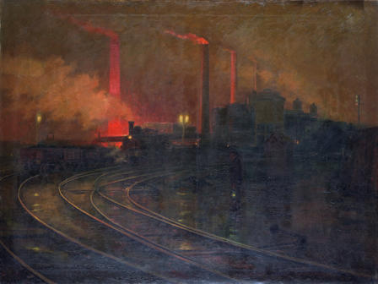Art in Wales (Landscape)

WALDEN, Lionel (1862 - 1933) (National Museum of Wales 2016)  
[Steel Works, Cardiff at Night](http://www.museumwales.ac.uk/art/online/?action=show_item&item=1860)

The museum represents many artists that have been attracted by the Welsh lands and industrial spots. For instance, the painting Steel Works, Cardiff at Night by Lionel Walden is one of the inspirational paintings that reflects the Cardiff industry in the eighteenth to nineteenth century (National Museum of Wales 2016).

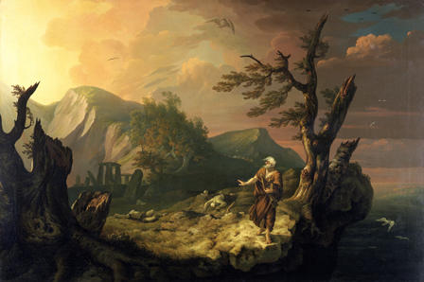

JONES, Thomas (1742 - 1803) (National Museum of Wales 2016)

[The Bard](http://www.museumwales.ac.uk/art/online/?action=show_item&item=1154)

In the 18th century, Welsh artists did not have good opportunities in Wales to learn more about art since there were not any art schools in Wales. Therefore, many of the Welsh artists moved to London to join in an art school (ibid). The National museum of Wales provides one of the fine arts by the Welsh artist Thomas Jones. The landscape background of the painting was inspired by the mythology and the history behind the bard story (ibid).

* 1. Welsh Pottery and Porcelain

The National Museum of Wales also reflects one of the Welsh professions and crafts which is pottery and porcelain. For Example, in the 1813 to 1826, the porcelain was made at Nantgarw in the Cardiff area (National Museum of Wales 2016). In the Pottery and Porcelain section of the museum, there are many different vases that were painted by Welsh artists, such as Mary Moggridge who painted the Swansea pair of porcelain in 1819. In addition, the Joseph gallery holds many different old Welsh pottery and statues. Therefore, the professions in Wales play an important role for the welsh culture and the museum promotes this side of the Welsh culture.

* 1. The Evolution of Wales

The evolution of Wales’s exhibition covers most of the museum’s space, and it one of the most interesting section in the museum (National Museum of Wales 2016). Furthermore, the evolution of Wales’s section illustrates how Wales has been evolving it terms of geology and landscapes. This exhibition of the museum is very well organized and it includes many old skeleton structures of rare and ancient animals that lived in south Wales. The presentation of the items and how they teach you about the big bang incident that created the universe. Then it slowly narrows on how Wales rose to the surface of the earth has been shown in a unique way. All of the geological evolution was shown in one of its sections that makes it easier for the visitors to understand, where all were explained in a dark room with a wide multiple screens surrounded by old rocks that gives the visitor the experience to learn about how Wales looked like in its earlier stages and enjoy their time as well.

1. Conclusion

In conclusion, the national museum of Wales highly promotes the Welsh culture in many different aspects such as Welsh art and artists, of their old professions like pottery, and wide information about the evolution of the Wales’s landscape. Since there are many visitors from around the world, the museum supports translation for various languages. It also provides tours that are led by guiders to take the visitors around the museum and explain every piece in the museum. A further recommendation could improve the museum to reflect more of its Welsh identity is by providing a large exhibition that tells the Welsh history from beginning until now. Finally, the museum can be a good source for students who are willing to learn more about the Welsh culture and the United Kingdom in general.

Reference List:-

The National Museum of Wales. 2016. [Online]. Available at: <http://www.museumwales.ac.uk/cardiff/> [Accessed: 1 May 4, 2016].